Adventist University of Central Africa

ANALYTICAL SYSTEM FOR STUNTED GROWTH

CASE STUDY: RBC (Rwanda Biomedical Center)

Afinal year project

Presented in partial fulfillment of the

requirements for the degree of

BACHELOR OF SCIENCE IN INFORMATION TECHNOLOGY

Major in

INFORMATION MANAGEMENT

By

JURU YVAN PIERRE

September, 2022

# **PROJECT ABSTRACT**

Research Project for the Bachelor Degree in Information Technology

Emphasis in Information Management

Adventist University of Central Africa

**Title: Analytical System for Stunted Growth**

**Name of this researcher: JURU Yvan Pierre**

**Name and the degree of the faculty advisor: Dr SEBAGENZI Jason**

**Date completed: September 2022**

The major goal of this research was to develop a web-based application that would aid in the recording and analysis of children's data for better interpretation, as well as to assist pregnant women in keeping track of their food for a healthy birth.

To achieve the project's objectives, an analysis of the existing system was conducted, and issues that medical centers experience when recording interpreting and assessing children's measurements were discovered.

Following that, appropriate remedies to the raised issue were presented.

Analytical System for Stunted Growth is a web-based application that will allow hospitals/centers personnel to access information they need on patient, keep accurate record on patient records and help them to monitor patient progress.

# **DECLARATION**

I, **Yvan Pierre JURU**, with Registration No 22042, a student at the Adventist University of Central Africa in Faculty of Information Technology, Department of Information Management. I hereby, declare that this research project entitled “**ANALYTICAL SYSTEM FOR STUNTED GROWTH** “is entirely the real reflection of my own original work and has not received any previous credit at the Adventist University of Central Africa or any other University or Institution.

Signature: ………………………

Date: ………………….

# **APPROVAL**

I, **Dr Jason SEBANGENZI, Ph.D.,** hereby certify that this project has been done under my supervision and submitted with my approval.

Signature: ………………………

Date: ………………….

# **DEDICATION**

To my lovely family especially my parents

For their support during all the time of my studies.

To all my friends and relatives, without also

Forgetting my supervisor for his guidance.

This work is dedicated.

**TABLE OF CONTENTS**

PROJECT ABSTRACT ii

DECLARATION iii

APPROVAL iv

DEDICATION v

LIST OF ABBREVIATIONS ix

ACKNOWLEDGEMENT 1

CHAPTER 1 2

GENERAL INTRODUCTION 2

Introduction 2

Background of the study 2

Statement of the problem 3

Choice and motivation of the study 3

Objectives of the study 3

General objective 3

Specific objectives 3

Scope of the study 4

Methodology and Techniques used in the study 4

Expected results 5

Organization of the project 5

CHAPTER 2 6

ANALYSIS OF EXISTING SYSTEM 6

Introduction 6

Description of Current System Environment 6

Historical Background 6

Mission 6

Vision 6

Description of Current System 7

Analysis of the current system 7

Modelling of Current System 8

Problems of the Current System 8

Proposed Solutions 9

System requirements 9

Functional requirements 9

Non-Functional Requirement 10

CHAPTER 3 12

REQUIREMENTS ANALYSIS AND DESIGN OF THE NEW SYSTEM 12

Introduction 12

Analysis and Design Methodology 12

Analysis of the new system 12

Concepts of objects-oriented methodology 12

Unified Modeling Language (UML) 13

Design of the new system 14

Use Case Diagram 14

Use-case description 16

Class diagram 24

Sequence diagram 25

Database design 30

System Architecture Design 31

CHAPTER 4 33

IMPLEMENTATION OF THE NEW SYSTEM 33

Introduction 33

Technologies used 33

Graphical interface and presentation of Analytical System for Stunted Growth 34

Software Testing 40

Software and Hardware compatibility requirements 41

CHAPTER 5 43

CONCLUSION AND RECOMMENDATIONS 43

Conclusion 43

Recommendations 44

REFERENCES 45

APPENDICES 46

Curriculum Vitae 47

**LIST OF FIGURES**

Figure 1: Current system 8

Figure 2: Use case diagram 16

Figure 3: Class diagram 25

Figure 4: Sequence diagram for login 27

Figure 5: Sequence diagram for recording children data 28

Figure 6: Sequence diagram for record nurse 29

Figure 7: Sequence diagram for assigning user’s permission 30

Figure 8: Database diagram 31

Figure 9: Architectural design 32

Figure 10: Home page 34

Figure 11: Login page 35

Figure 12: Adding user 35

Figure 13: Adding nurse 36

Figure 14: Adding children 36

Figure 15: Adding heath centers 37

Figure 16: Adding parent 37

Figure 17: List of children 38

Figure 18: List of permissions 38

Figure 19: List of parents 39

Figure 20: Parent and User Dashboard 39

Figure 21: Children Dashboard 40

**LIST OF TABLES**

Table 1: Use case description for creating nurse 18

Table 2: Use case description for assigning food category 20

Table 3: Use case description for assigning permission 21

Table 4: Use case description for recording children data 22

Table 5: Use case description for recording parent data 22

Table 6: Use case description for viewing mother's nutrition timetable 23

Table 7: Use case description for viewing children nutrition timetable 24

Table 8: Diagram of element 26

# **LIST OF ABBREVIATIONS**

AUCA: Adventist University of Central Africa

CSS: Cascading Style Sheet

DB: Database

DBMS: Database Management System

HTML: Hyper Text Mark-up Language

HTTP: Hyper Text Transfer Protocol

IDE: Integrated Development Environment

IS: Information System

IT: Information Technology

MVC: Model View Controller

OMG: Object Management Group

OOM: Object Oriented Methodology

OS: Operating System

SDLC: Software Development Life Cycle

PHP: Hypertext Preprocessor

UML: Unified Modeling Language

# **ACKNOWLEDGEMENT**

First and foremost, my infinite gratitude goes to the Almighty God who has provided life and all needs instead of what I wanted. This is only one in many other miracles you have done to me.

I genuinely offer my recognitions to the academic staff of the department of Information Technology and the whole Administration at large at the Adventist University of Central Africa for the work done during my stay at the University, the knowledge that was acquired helped me to conduct this work, and I take this opportunity to thank the whole AUCA staffs.

My sincere gratitude goes to my supervisor, Mr. SEBAGENZI Jason for his wise technical advice, suggestions and corrections that made this research project fruitful.

Special thanks also to my Parents, my dear beloved brothers, sisters and family who have always encouraged and supported me during my studies to the completion of this work. No one is truly self-made; hence I pass on a cordial thanks to my colleagues at AUCA

Finally, I express my gratitude to each and every one who directly and indirectly contributed to make my studies, to be honest they played a very big role in my time here at AUCA.I can’t thank you enough.

May the Almighty God bless you all abundantly.

# **CHAPTER 1**

# **GENERAL INTRODUCTION**

## **Introduction**

Rwanda's shift to a knowledge-based economy is being driven by information and communication technology. Rwanda has been continuously developing its ICT sector since 2000, thanks to its decision to make ICT its key motor. Rwanda began by laying the groundwork for the ICT industry, including developing institutional, legal, and regulatory frameworks, as well as lowering entry barriers to the telecom market. Rwanda then focused on improving its ICT infrastructure by constructing a national data center that centralizes data storage, management, and protection while also utilizing cloud computing. Rwanda currently aims to concentrate on upgrading and enhancing e-government and cyber-security, as well as focusing on skills, private sector and community development.

Following the government's intentions, it is necessary to digitize everything, which includes not only access and connectivity, but also digitizing services in order to create a less corrupt and transparent environment. Taking our government as an example, we should establish transparent, innovative solutions that start with our neighborhood and then expand to the rest of the country.

Analytical System for Stunted Growth is a web platform that simplifies the reporting process and will allow hospitals/centers personnel to access information they need on patient, keep accurate record on patient records and help them to monitor patient progress.

## **Background of the study**

Since Rwanda has limited minerals, its development relies on a solid base of human resources, qualified in science and technology, with particular emphasis on Information and Communication Technologies (ICT). On the development front, the role of ICT is crucial to modernize and boost the Rwandan economy and society, using the technologies as an engine for acceleration of economic growth.

As to reach economic growth, it is advised to develop a community and the country at large whereby we use advanced technologies like web portals and mobile applications in order to improve access to and use of information.

Analytical System for Stunted Growth is a web-based application that will allow hospitals/centers personnel to access information they need on patient, keep accurate record on patient records and help them to monitor patient progress.

## **Statement of the problem**

Stunting is one of the main challenges resulting in high child mortality and morbidity thought out the world, especially in many developing countries, including Rwanda. The overall prevalence rate of One of the measures of undernutrition that represents chronic undernutrition is “stunting”, characterized by the deceleration or arrest of growth. This is due to long-term insufficient nutrient intake. Stunting is a serious problem that impacts negatively cognitive growth, academic achievement and work outcomes in later-life. The high prevalence of stunting is a result of several factors like Inadequate diet, Repeated infection, Inadequate medical care. Over the past two decades, Rwanda has experienced impressive economic growth, resulting in considerable improvements in living standards and poverty reduction. Despite these gains, progress on reducing the level of stunting in smallholder rural children, particularly boys, continues to be a serious concern.

## **Choice and motivation of the study**

According the above stated problems, the motivation to conduct this study is the technological evolution that’s going all around the world.

As John Dewey said “A problem well stated is a problem half solved.” This is a motivation to always solve every problem encountered hence developing a web portal for recording, analyzing children information for better interpretation and help pregnant woman to keep track of their diet for healthy delivery

## **Objectives of the study**

### **General objective**

The overall purpose of this study is to develop a web portal that will help in recording, analyzing children information for better interpretation and help pregnant woman to keep track of their diet for healthy delivery

### **Specific objectives**

* To analyze problems within the existing system and build up an improved system.
* To design a database where information regarding the system will be stored.
* To create a system that will be secure so that only authorized people will be granted access.
* To create a friendly and easy to use system.

## **Scope of the study**

This study will be limited to the design and development of a web application prototype which enable doctors from different location to get access to information about children (from 0 to 2 months) and mothers of their dietary and health status on nutritive basis. This prototype will cover activities of the medical centers.

## **Methodology and Techniques used in the study**

Methodology is the process used to collect information and data for the purpose of making decisions. The methodology may include publication research, questionnaires, surveys and other research techniques and could include both present and historical information. The following are techniques and methods used in conducting this research.

**Observation**

In descriptive sociological studies, the observation method has played a significant role. It is the most important and widely used data collection method. The purpose of questionnaire response analysis is to figure out what individuals believe and do base on what they write down. What people say in a discussion with the interviewer reveals the interviewee's replies. Observation is the process of determining what individuals think and do by seeing them express themselves in a variety of circumstances and activities (Akash C.,2019).

**Interview**

The interview as a data-gathering technique is quite popular and widely employed in all fields of social research. In some ways, the interview resembles an oral questionnaire. The interviewee or subject offers the necessary information verbally in a face-to-face relationship rather than writing it down. However, the dynamics of interviewing entail far more than a spoken query (Akash C.,2021).

## **Expected results**

This new system is expected to produce the following output:

* Reduce time wasted in reporting processing.
* Less amount of money used to purchase materials to be used for recording data.
* To generate weekly food diary
* Keep accurate records on patient records.

## **Organization of the project**

This research study consists of five chapters which include the following:

The first chapter namely, General introduction will provide the basic information of this study like what made me choose this particular study and what motivated me, the overview of the problem we intend to solve, the methods and techniques used in collection of data, the objectives, the scope and the expected output of the study.

The second chapter namely, Analysis of the existing system will mostly emphasize on the description of existing system in depth, its design, its problems, and my proposed solution.

Requirements analysis and design of the new system, the third chapter, will mostly discuss the new system in detail. A brief description of its UML and the design aided by use-case diagrams, sequence diagram, activity diagram, data dictionary diagram, and architecture diagrams.

The fourth chapter called Implementation of the new system will focus mainly on the practical aspect of the study. We will explain how the new system was built by describing and presenting screenshots of my codes as forms of data entry and reports, we will also provide the technologies used to build and develop this software.

The fifth chapter namely, Conclusions and recommendations will conclude my research and will contain recommendations for future development.

# **CHAPTER 2**

# **ANALYSIS OF EXISTING SYSTEM**

## **Introduction**

System analysis is the process of studying procedure or business in order to identify its goals and purposes and create systems and procedures that will be achieve them in an efficient way. This chapter will aid us in developing a comprehensive understanding of the current system, which is essential for the development of the new system. We must recognize and emphasize issues with the current system and think through potential improvements if we are to have a clear picture of the new system. We will also go through how activities are monitored and evaluated, to better understand the existing system, we will provide a brief description of the institution, its working principles and values, problems faced within the system, all its features and characteristics and a brief presentation about terms and terminologies used during the development of the project.

## **Description of Current System Environment**

### **Historical Background**

Rwanda Biomedical Centre (RBC) is the nation's central health implementation agency.

RBC was established in 2011 through a merger of fourteen key health institutions. RBC strives to improve the health of the Rwandan population by providing high quality, affordable and sustainable health care services. This is accomplished through the implementation of preventative, rehabilitative, and curative health interventions.

RBC conducts scientific research, provides diagnostics services, and implements innovative health interventions to protect the nation against diseases and other health threats.

### **Mission**

To promote high quality affordable and sustainable health care services to the population through evidence-based interventions and practices innovative guided by ethics and professionalism.

### **Vision**

To become a Center of Excellence for the prosperity of the country, ensuring quality health service delivery, education and research.

## **Description of Current System**

The existing system analysis is the process of examining a business situation for the purpose of developing a system solution to a problem or devising improvements to such a situation. To successfully implement a new system, it is essential to fully understand the existing one. In system analysis, focus is placed more on comprehending the specifics of an existing or proposed system before determining whether or not the new system is desirable and whether the current system needs to be improved. As a result, system analysis is the act of looking into a system, detecting issues, and using the information to suggest system improvements.

Nowadays the existing system proceeds in manually way. The maternal child health nurse takes measures of the children and record their data in books

Stunting occurs when a child does not have sufficient nutrition to grow and develop. This can be caused by a poor diet alone, but is often exacerbated by disease and poor health

maternal child health nurse has no historical access to medical record of their patient

## **Analysis of the current system**

The existing system operates in main features which include the following:

* **Information assembly**: at this stage every maternal child health nurse from different region provides information on each record they took
* **Analysis of data**: At this stage, data is analyzed from different hospitals/health centers and reports are made and sent to RBC.
* **Report review**: At this final stage, they review reports and interpret them from different hospitals/health centers to get a view on the situation in the country

### **Modelling of Current System**

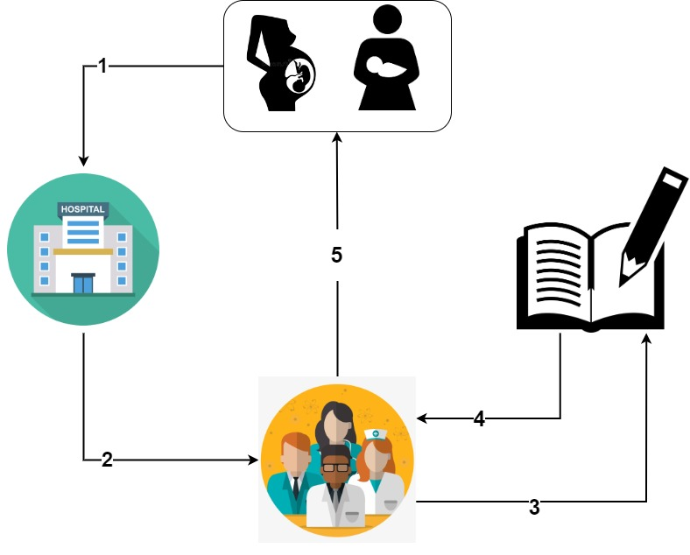

Figure 1: Current system

### **Problems of the Current System**

Below are the problems encountered after realizing that there would be a better, easier, and faster way if health personnel could access the right information from their patient’s system for help via a web browser.

The current system faces many problems, including the following:

* **Manual System**: the patient’s medical records are stored in paper-based way.
* **Data Collection**: It is difficult to get immediate and accurate data or information on the status of stuntedness in Rwanda.
* **Wastage of resources**: in terms of money the health centres use a lot of money purchasing materials such as books for medical records.
* **Lack of Security**: unauthorized personnel can have access to the data and temper with it
* **Poor Management**: as we know the patient’s medical records are kept manually on paper forms. this may cause data loss, Inconsistency in data entry, room for errors, mis-keying information
* **Time Consuming**: difficulty when it comes to time management. patient’s medical records Information processing by recording and filling forms for data entry, it takes long time and delays for finding recorded hardcopy

## **Proposed Solutions**

According to the mentioned problems above, this new system will bring the following solutions:

* Reduce time wasted in reporting processing.
* Keep accurate record on patient records.
* uses manual process of record keeping such as a handwritten document, keeping records inside the drawer that sometimes tends to lose, unsecured storage of all data and information dissemination about the health status is also problematic. I decide to make it online they will be stored in database.
* Record keeping will be safe with only authorized personnel getting access to it and retrieving it in the minimum possible time.
* The reduction in medical errors directly reduces costs for both the practitioners and patients. By leveraging technology to reduce diagnosis and prescription errors.

## **System requirements**

Functional requirements are those requirements that are easier to be found at the starting moment and non-functional requirements, also called quality requirements define the system properties and constraints.

### **Functional requirements**

The following are some of the functional requirements of the online voting system:

* Information should be able to be saved by the system into the database.
* Administrators should be able to request activity reports from the system.
* The administrator should have access to the system to add, edit and delete patient account
* The system should be to create or record a user’s information.
* Admin should be able to Backup database
* Admin should be able to Login, logout, change password
* Admin should be able to Login, logout, change password
* RBC should be able to manage admins
* RBC should be able to view report from different health centers

### **Non-Functional Requirement**

**Security**

* The system must encrypt user passwords.
* The system should provide right privileges according to user type.
* Users have to login in order to perform any useful action.

**Performance**

* Within 10 seconds, the system must respond to user’s request.
* In the event of outage, the system shouldn't operate for longer than 20 seconds.
* User request will not exceed 2 clicks in maximum to be completed.
* The system will be running for 24 hours a day.

**Accessibility**

* A laptop or other programmed electronic device, such as a computer, phone, or tablet, should be able to access the system.
* Anyone who requires the system should be able to access it online.
* All authorized users must have access to the system processes.

**Maintainability**

* When desired, the system should be simple to maintain.

**Data integrity**

* The user's privacy should be able to be protected by the system.

**Technical**

* The system is a web application project, which include PHP with its popular framework known as LARAVEL and MYSQL as database.
* The system should be running on both Windows and Linux platforms i.e., through application and database servers.
* The database server and the application server should be on different servers.

## **CHAPTER 3**

## **REQUIREMENTS ANALYSIS AND DESIGN OF THE NEW SYSTEM**

## **Introduction**

The study of the current system was done in chapter 2, therefore in order to create a strong and effective system that satisfies user needs, a proper analysis and clear design are needed, just as a strong foundation is crucial for a strong superstructure.

Typically, system development consists of two key parts:

* **System Analysis**: It is a process of collecting and interpreting facts, identifying the problems, and decomposition of a system into its components. It is conducted for the purpose of studying a system or its parts in order to identify its objectives. It is a problem-solving technique that improves the system and ensures that all the components of the system work efficiently to accomplish their purpose
* **System Design**: It is a process of planning a new business system or replacing an existing system by defining its components or modules to satisfy the specific requirements. Before planning, you need to understand the old system thoroughly and determine how computers can best be used in order to operate efficiently.

System Design focuses on how to accomplish the objective of the system.

## **Analysis and Design Methodology**

### **Analysis of the new system**

The system analysis phase provides answers to the questions of who will use the system, what it will do, where it will be utilized, and when. The manager of the possible system and/or systems analysts must write a project proposal before any work on developing a system can start, and it must be submitted to the proper managerial structure within the company.

### **Concepts of objects-oriented methodology**

A system development methodology called object-oriented methodology (OOM) promotes and facilitates the reuse of software components. This methodology permits the efficient reuse of existing components and makes it easier for other systems to share the components of a computer system that is designed on a component basis.

They are two main basic building blocks that are useful in development of the system by using Object Oriented Methodology: Classes and Objects.

A distinct entity with a clearly defined boundary that incorporates states and behavior expressed as a software representation is referred to as an object. It is an instance of a class. A thing, an idea, or an event can all be considered objects. Simply put, a class is a description of a group of objects with common properties and behaviors once you understand what an object implies. (Alan, 2005)

Typically, use cases and abstract definitions of the most crucial objects are used in object-oriented modeling. The Unified Modeling Language is the most widely used language

### **Unified Modeling Language (UML)**

In the area of software engineering, the Unified Modeling Language (UML) is a general-purpose modeling language that aims to offer a standardized method of visualizing system architecture. A common notation for modeling object-oriented systems is this one.

Grady Booch, Ivar Jacobson, and James Rumbaugh created it in the 1990s while working at Rational Software. Since the Object Management Group (OMG) adopted it in 1997, this group has been in charge of overseeing it. The International Organization for Standardization (ISO) approved the Unified Modeling Language as a standard for modeling software-intensive systems in 2000.

Unified Modeling Language (UML) combines techniques from data modeling (entity relationship diagrams), business modeling (work flows), object modeling, and component modeling. It can be used with all processes, throughout the software development life cycle, and across different implementation technologies (Louis Rivest, 2002).

The Unified Modeling Language (UML) provides a common method to see a system's architectural blueprints, which may include things like:

* activities
* actors
* business processes
* database schemas
* (logical) components
* programming language statements
* Reusable software components.

UML has synthesized the notations of the Booch method, the Object-modeling technique (OMT) and Object-oriented software engineering (OOSE) by fusing them into a single, common and widely usable modeling language. UML aims to be a standard modeling language which can model concurrent and distributed systems (Jeffrey L. & et al, 1998).

## **Design of the new system**

System design is the first phase of the system development life cycle in which you and the user develop a concrete understanding of how the system will operate.

Systems design is the process of defining the architecture, components, modules, interfaces, and data for a system to satisfy specified requirements.

### **Use Case Diagram**

Use case diagram is UML diagram which shows some business or software system, its external users (called [actors](http://www.uml-diagrams.org/use-case-actor.html)), and a set of actions (called [use cases](http://www.uml-diagrams.org/use-case.html)) that users of the system should or can perform while using the system. Use case diagrams are used to describe functionality of a system from the point of view of external users (Jeffrey L, 2007).

The use case is made up of a set of possible sequences of interactions between systems and users in a particular environment and related to a particular goal. It consists of a group of elements (for example, classes and interfaces) that can be used together in a way that will have an effect larger than the sum of the separate elements combined

Use case diagrams consist of actors, use cases and their relationships. The diagram is used to model the system/subsystem of an application. A single use case diagram captures a particular functionality of a system.

Use case diagrams are used to gather the requirements of a system including internal and external influences. These requirements are mostly design requirements. Hence, when a system is analyzed to gather its functionalities, use cases are prepared and actors are identified.

The symbols below are used in use case diagram:

**Actor**

An actor specifies a role played by a user or any other system that interacts with the subject.



**Use case**

The use case is a specification of sequences of actions that a system can perform by interacting with outside actors; it is something an actor wants a system to do and is represented as follows:



**Relationship**

Meaningful relationships between actors and use cases which is a UML association symbol.



**System boundary**

It is a box drawn around the use case to denote the edge or boundary of the system being modeled.

System boundary

The figure below describes the operations of the new system and the stakeholders through the use case diagram.

**Use case Diagram**

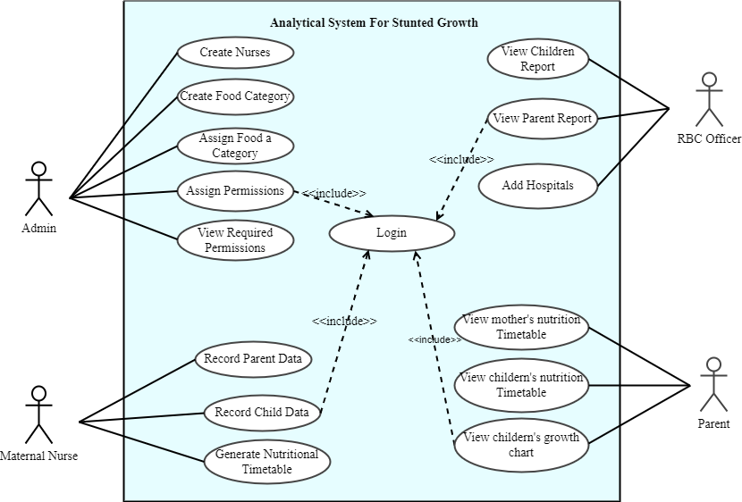

Figure 2: Use case diagram

### **Use-case description**

Use Case description details what a use case does, and what it requests in order to be well executed. Each use case looks like this:

* **Name**: A name of a use case
* **Description**: What a system intends to do
* **Actor**: The actor involved in the use case
* **Pre-condition**: The system state before the use case can begin
* **Post-condition**: The system state when the use case is over
* **Normal flow**: The actual steps of the use case
* **Alternative flow**: Steps which may happen in case a normal flow fails.

**Use case description for Managing Nurse**

|  |
| --- |
| **Name**: Create Nurses |
| **Actor:** Admin |
| **Description:** This allows the admin to update, delete, view and modify nurses |
| **Pre-condition:** Admin should first login in order interact with the system |
| **Post-condition:**  **Delete Nurse**  the nurse is removed from the system or the system fails to remove her.  **Update Nurse**  the nurse is updated or the system fails to update the nurse. |
| **Normal flow:**  1. The admin requests the page where nurses are displayed.  2. The system displays requested page  3. The admin view the nurses  Edit/Update nurses  1. The admin press the update button  2. The system displays requested page  3. The admin modifies the nurse's information.  4. The system validates and checks errors based on requirements  5.The system redirects back to the main page contains all nurses with success message  Delete/remove nurses  1. The admin press the delete button  2. The system prompts a message for deletion  3. The admin confirms the deletion  4. The system prompts a message for deletion  5. The system validates and delete the nurse |
| **Alternative flow**:  Delete selected nurse  4. If the information is not valid, the system provides the message indicating the error.  5.If the system fails to delete information displays the failure message  Updating selected nurse  4. If the information is not valid, the system provides the message indicating the error  5. If the system fails to update information displays the failure message |

Table 1: Use case description for creating nurse

|  |
| --- |
| **Name**: Assign Food Category |
| **Actor:** Admin |
| **Description:** This allows the admin to assign food to a category |
| **Pre-condition:** Admin should first login in order interact with the system |
| **Post-condition:**  **Delete Foods**  The food is removed from the system or the system fails to remove it.  **Update Foods**  The food is updated or the system fails to update the nurse. |
| **Normal flow:**  1. The admin requests the page where foods are displayed.  2. The system displays requested page  3. The admin view the nurses  Edit/Update foods  1. The admin press the update button  2. The system displays requested page  3. The admin modifies the food details.  4. The system validates and checks errors based on requirements  5.The system redirects back to the main page contains all food categories with success message  Delete/remove foods  1. The admin press the delete button  2. The system prompts a message for deletion  3. The admin confirms the deletion  4. The system prompts a message for deletion  5. The system validates and delete the nurse |
| **Alternative flow**:  Delete selected food  4. If the information is not valid, the system provides the message indicating the error.  5.If the system fails to delete information displays the failure message  Updating selected food  4. If the information is not valid, the system provides the message indicating the error  5. If the system fails to update information displays the failure message |

Table 2: Use case description for assigning food category

**Use case description for Assigning Permissions**

|  |
| --- |
| **Name**: **Assign Permission** |
| **Actor:** Admin |
| **Description:** This allows the admin to give permissions |
| **Pre-condition:** the admin should first login in order interact with the system |
| **Post-condition:**  **Assign Permissions**  Admin can give permissions according to the users |
| **Normal flow:**  Manage permissions  1. The admin requests the page where he can give or take permissions  2. The system displays requested page  3. The admin update/remove some permission of the user  4.The page indicating all permissions is displayed with success message  Give/Take user’s permissions  1. The admin requests the page containing all Users  2. The system displays requested page  3. The admin selects the user to change permission  4. The system validates the information.  5. The page display the new permissions |
| **Alternative flow**:  Manage Permission  1. If the system fails to update/remove information displays the failure message |

Table 3: Use case description for assigning permission

**Use case description for Record Children**

|  |
| --- |
| **Name:** Record Child Data |
| **Actor:** Maternal Nurse |
| **Description:** Help the nurses access the system. the nurse’s account is managed by the admin |
| **Pre-condition:** the Nurse should first login in order interact with the system |
| **Post-condition:**  **Record Child Data**  Maternal Nurse can record children information |
| **Normal flow:**   1. the nurse requests the page where he/she can make consultation 2. System displays a form to fill the identification information, 3. the nurse fills in the requested data, 4. The system validates the information, 5. System sends a message to user and displays a notification on the screen |
| **Alternative flow:**  Manage children   * 3. If the information is not valid, the system provides the message indicating the error * 3. The nurse fills and sent the information again. |

Table 4: Use case description for recording children data

|  |
| --- |
| **Name:** Record Parent Data |
| **Actor:** Maternal Nurse |
| **Description:** Help the nurses access the system. the nurse’s account is managed by the admin |
| **Pre-condition:** the Nurse should first login in order interact with the system |
| **Post-condition:**  **Record Parent Data**  Maternal Nurse can record mother’s information |
| **Normal flow:**   1. the nurse requests the page where he/she can make consultation 2. System displays a form to fill the identification information, 3. the nurse fills in the requested data, 4. The system validates the information, 5. System sends a message to user and displays a notification on the screen |
| **Alternative flow:**  Manage parent   * 3. If the information is not valid, the system provides the message indicating the error * 3. The nurse fills and sent the information again. |

Table 5: Use case description for recording parent data

|  |
| --- |
| **Name**: View Mother’s Nutritional Timetable |
| **Actor:** Parent |
| **Description:** This allows the parent to view mother’s nutritional timetable |
| **Pre-condition:** the parents should first login in order interact with the system |
| **Post-condition:**  **View Timetable**  parents can view nutritional timetable |
| **Normal flow:**  View her nutritional timetable  1. The parent requests the page where he/she can view her nutritional timetable  2. The system displays requested page  3.The page indicating mother’s nutritional timetable is displayed with success message |
| **Alternative flow**:  View nutritional timetable  1. If the system fails to update/remove information displays the failure message |

Table 6: Use case description for viewing mother's nutrition timetable

|  |
| --- |
| **Name**: View Children’s Nutritional Timetable |
| **Actor:** Parent |
| **Description:** This allows the parent to view children’s nutritional timetable |
| **Pre-condition:** the parents should first login in order interact with the system |
| **Post-condition:**  **View Timetable**  parents can view nutritional timetable |
| **Normal flow:**  View his/her nutritional timetable  1. The parent requests the page where he/she can view his/her nutritional timetable  2. The system displays requested page  3.The page indicating children’s nutritional timetable is displayed with success message |
| **Alternative flow**:  View nutritional timetable  1. If the system fails to update/remove information displays the failure message |

Table 7: Use case description for viewing children nutrition timetable

### **Class diagram**

A class diagram is the structure diagram that describes the structure of a system by showing the system's classes, their attributes, operations (or methods), and the relationships among the classes. The figure below shows the class diagram of the national budget preparation information system.

**Benefits of class diagrams**

Class diagrams offer a number of benefits for any organization. Use UML class diagrams to:

* Illustrate data models for information systems, no matter how simple or complex.
* Better understand the general overview of the schematics of an application.
* Visually express any specific needs of a system and disseminate that information throughout the business.
* Create detailed charts that highlight any specific code needed to be programmed and implemented to the described structure.

**SCHEMA OF CLASS DIAGRAM**

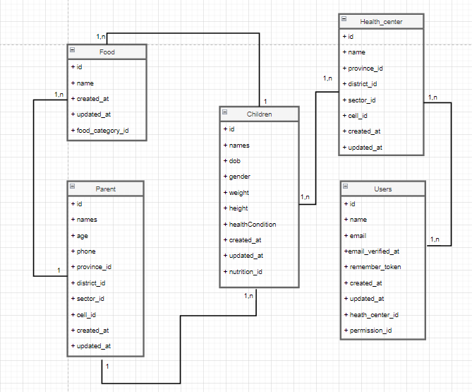

*Figure 3: Class diagram*

### **Sequence diagram**

A sequence diagram is a form of interaction diagram which shows objects as lifelines running down the page, with their interactions over time represented as messages drawn as arrows from the source lifeline to the target lifeline. A sequence diagram shows object interactions arranged in time sequence.

They capture the interaction between objects in the context of a collaboration. Sequence Diagrams are time focused and they show the order of the interaction visually by using the vertical axis of the diagram to represent time, what messages are sent and when.

The notations and their definitions that are used in sequence diagram:

|  |  |
| --- | --- |
| Term and definition | Symbol |
| An actor:   * It can be a person or system that derives benefit from and is external to the system. * It participates in a sequence by sending and/or receiving messages. * It is placed across the top of the diagram. |  |
| An object lifeline:   * It participates in a sequence by sending and/or receiving messages. * It is placed across the top of the diagram. |  |
| An activation:   * It is a long narrow rectangle placed on top of a lifeline. * It denotes when an object is sending or receiving messages |  |
| message:   * It conveys information from one object to another. * An operation call is labeled with the message being sent and a solid arrow, whereas a return is labeled with the value being returned and shown as a dashed arrow. |  |

Table 8: Diagram of element

**Sequence diagram for login** 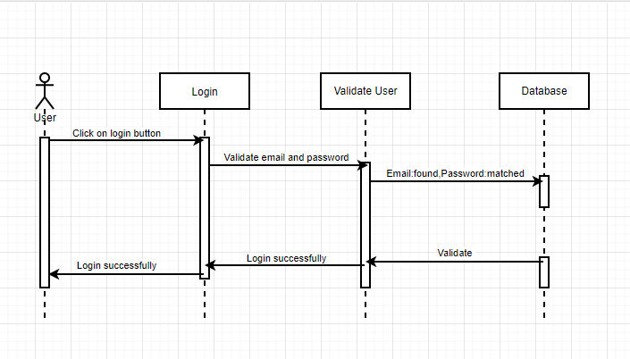

Figure 4: Sequence diagram for login

**Sequence diagram for recording children**

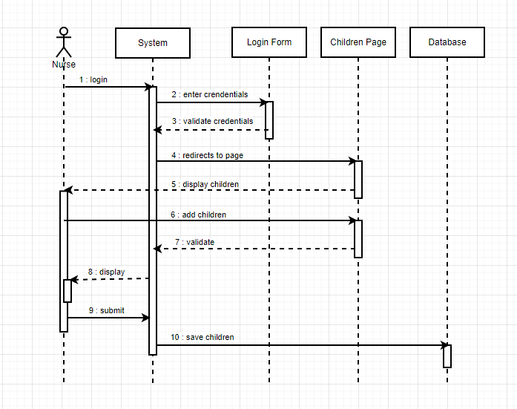

Figure 5: Sequence diagram for recording children data

**Sequence diagram for recording nurses**

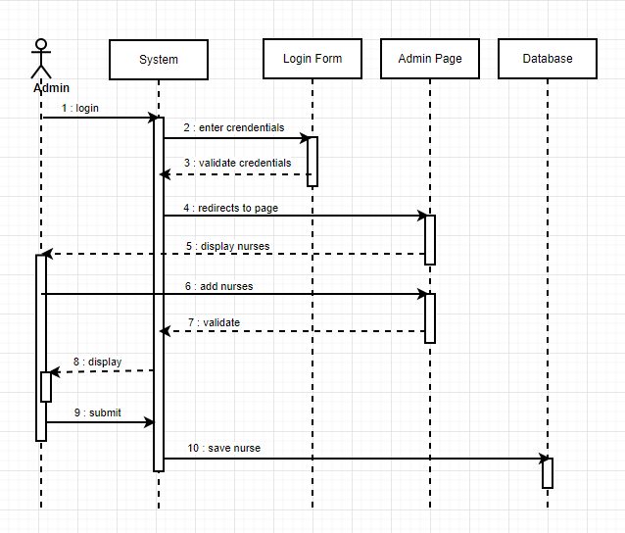

Figure 6: Sequence diagram for record nurse

**Sequence diagram for assigning permission**

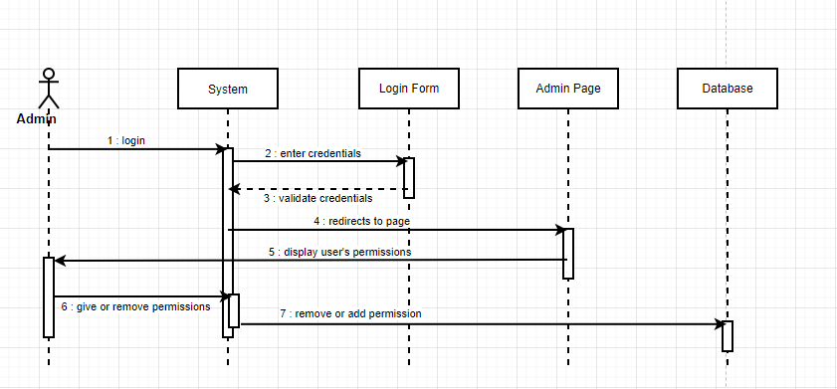

Figure 7: Sequence diagram for assigning user’s permission

### **Database design**

It is the process of producing a detailed data model of database. This data model contains all the needed logical and physical design choices and physical storage parameters needed to generate a design in a data definition language, which can then be used to create a database.

***Database Schema diagram***

A database schema of a database system is its structure described in a formal language supported by the database management system (DBMS) and refers to the organization of data to create a blueprint of how a database will be constructed (divided into database tables). The formal definition of database schema is a set of formulas (sentences called integrity constraints imposed on a database. These integrity constraints ensure compatibility between parts of the schema (Ramez& et al, 2004).

**DATABASE SCHEMA DIAGRAM**

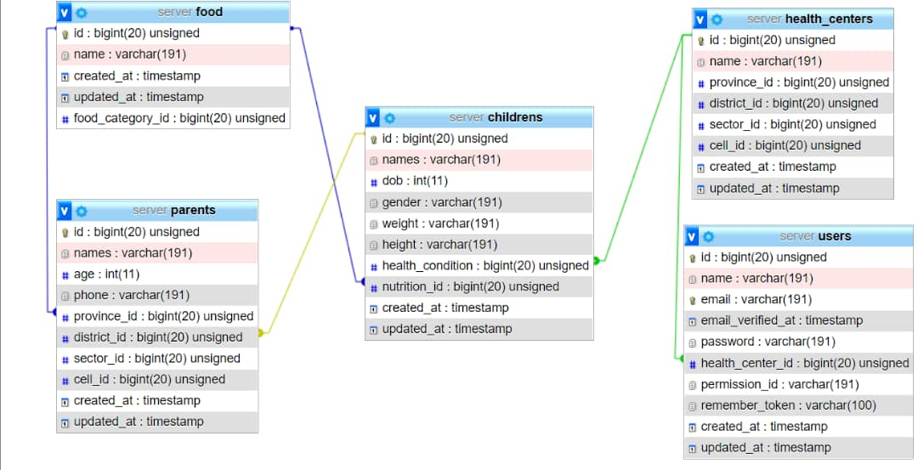

Figure 8: Database diagram

### **System Architecture Design**

System architecture is a representation of a system in which there is a mapping of functionalities into hardware and software components, a mapping of the software architecture onto the hardware architecture, and human interaction with these components. The following figure displays sample system architecture of the new application.

It is a diagram of a system, in which the principal parts or functions are represented by blocks connected by lines that show the relationships of the blocks.

**Architectural design**

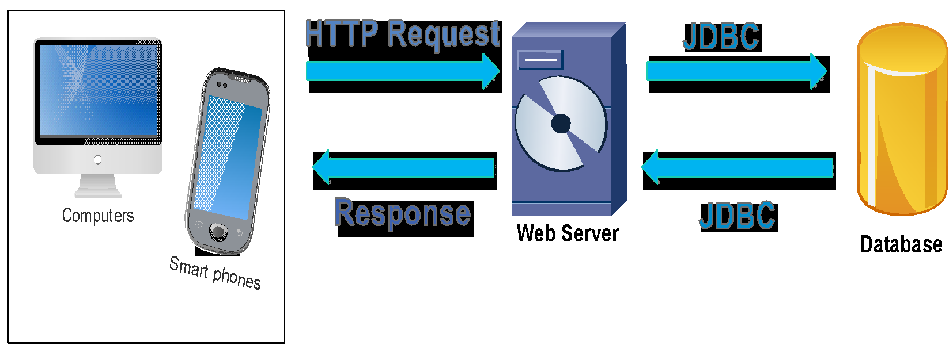

Figure 9: Architectural design

Our system architecture can be deeply explained by the MVC model (model view controller). Model view controller (MVC) is a very useful and popular design pattern. Since we’re software developers, we should know it. Fortunately, it’s also one of the simplest to truly understand.

# **CHAPTER 4**

# **IMPLEMENTATION OF THE NEW SYSTEM**

## **Introduction**

This chapter describes the development of “ANALYTICAL SYSTEM FOR STUNTED GROWTH”. It includes a brief overview of the technologies used to make the application

operational, the presentation of screenshots for the new system, tests that have been applied. Last but not least, software and hardware compatibility requirements.

## **Technologies used**

To develop this application, I have used different technologies and tools namely:

**MySQL:** is a software development tool used to develop a database as a collection of data. The purpose of a database is to store and retrieve related information. (Vaughan-Nichols, 2013)

**XAMPP:** Cross-Platform (X), Apache (A), MySQL (M), PHP (P) and Perl (P) is a free and open-source cross-platform web server solution stack package developed by Apache Friends, consisting mainly of the Apache HTTP Server, MariaDB database, and interpreters for scripts written in the PHP and Perl programming languages.

**HTML:** HTML (Hyper Text Markup Language) is written in the form of HTML elements consisting of tags enclosed in angle brackets (like <html>), within the web page content. HTML tags most commonly come in pairs like <h1> and </h1>, although some tags, known as empty elements, are unpaired, for example <img/>. The first tag in a pair is the start tag, the second tag is the end tag (they are also called opening tags and closing tags).HTML allows images and objects to be embedded and can be used to create interactive forms.

**APACHE WEB SERVER:** is the most widely used web server software developed and maintained by Apache software foundation.

Apache is an open-source software available for free

**Diagram.net/Drawio:** will be used to create the data model (Database schema and class diagram for the system)

**CSS:** Cascading style sheets are used to format the layout of web pages. They can be used to define text styles, table sizes, and other aspects of Web pages that previously could only be defined in a page's HTML.CSS makes it easy to change styles across several pages at once. (Petrie, et al, 2010).

**PHP (Stands for Hypertext Preprocessor):** is a server-side scripting language created in 1995 and designed for web development but also used as a general-purpose programming language. PHP code can be simply mixed with HTML code, or it can be used in combination with various templating engines and web frameworks. PHP code is usually processed by a PHP interpreter,

which is usually implemented as a web server’s native module or a Common Gateway Interface executable. After the PHP code is interpreted and executed, the web server sends resulting output to its client, usually in the form of a part of the generated web page; for example, PHP code can generate a web page’s HTML code, an image, or other data. And it can be built in Apache as a server. (Nixon, 2009).

## **Graphical interface and presentation of Analytical System for Stunted Growth**

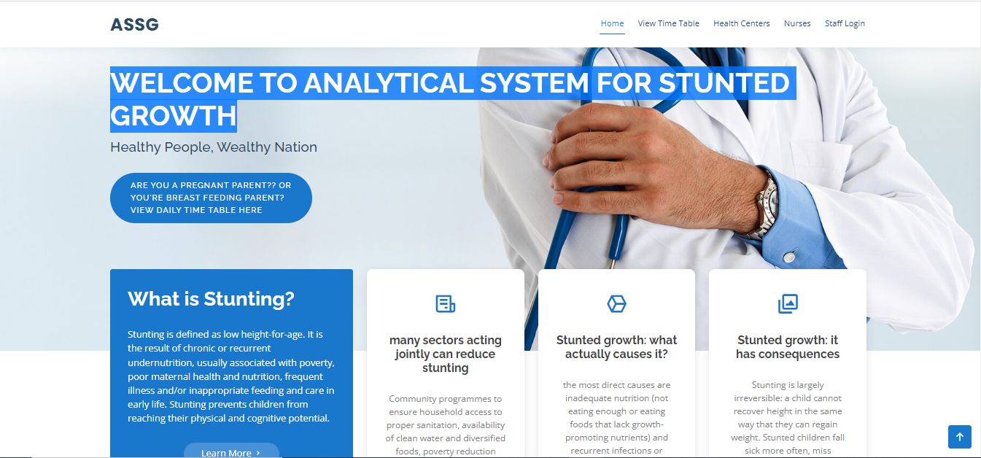

Figure 10: Home page

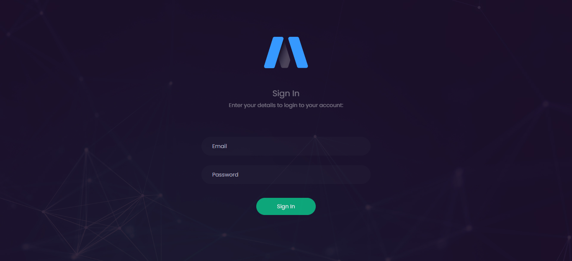

Figure 11: Login page

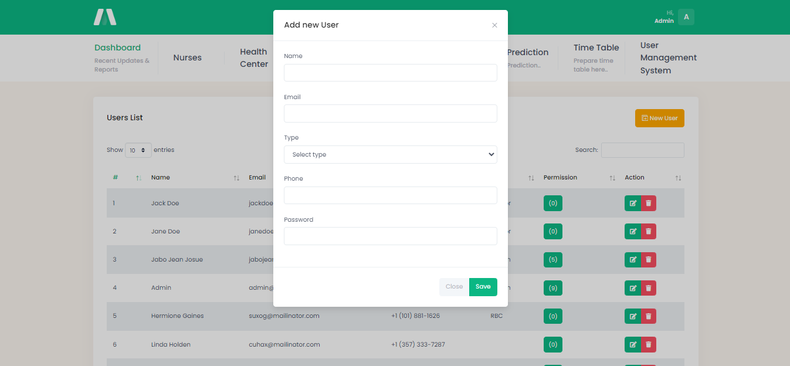

Figure 12: Adding user

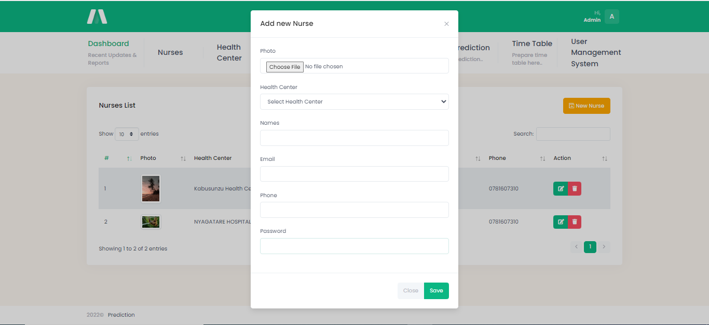

Figure 13: Adding nurse

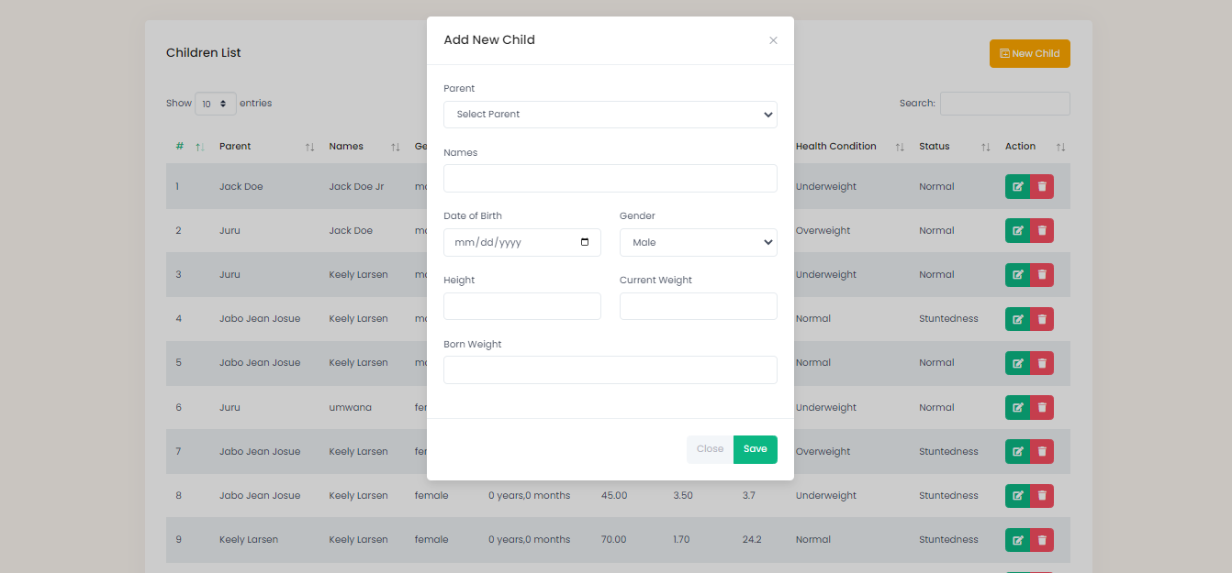

Figure 14: Adding children

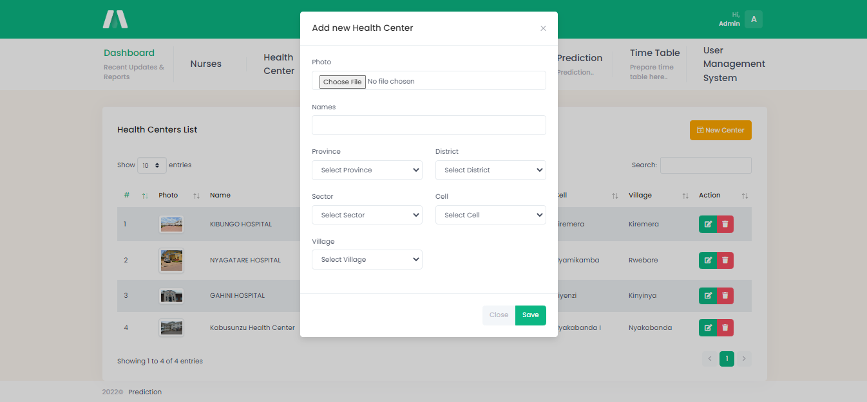

Figure 15: Adding heath centers

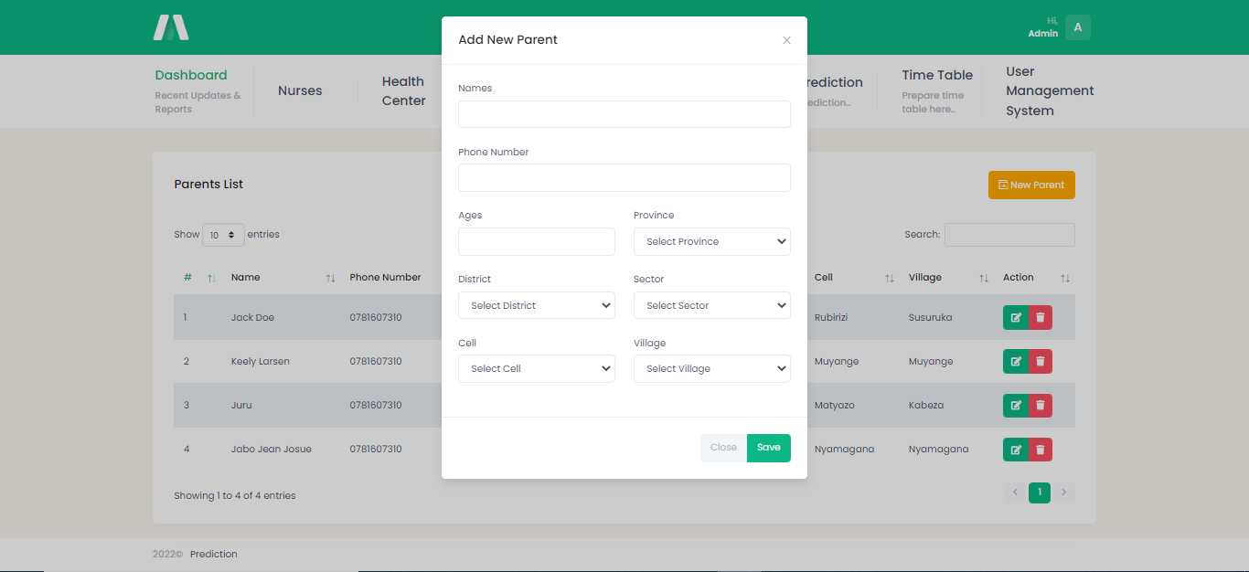

Figure 16: Adding parent

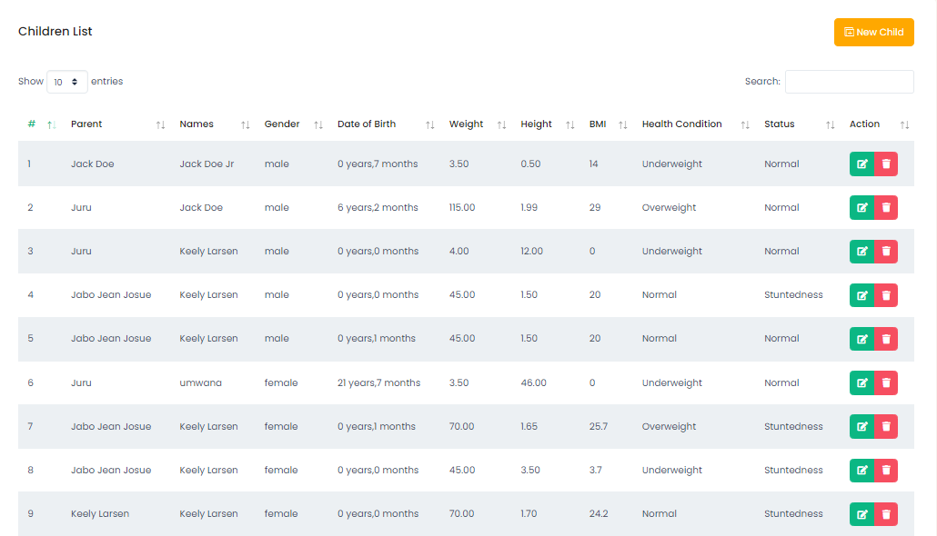

Figure 17: List of children

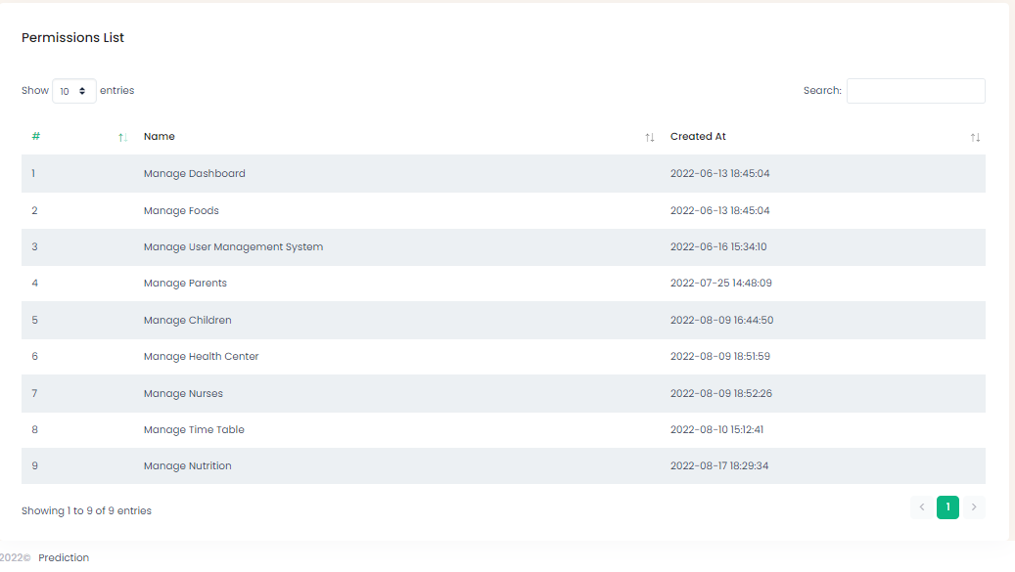

Figure 18: List of permissions

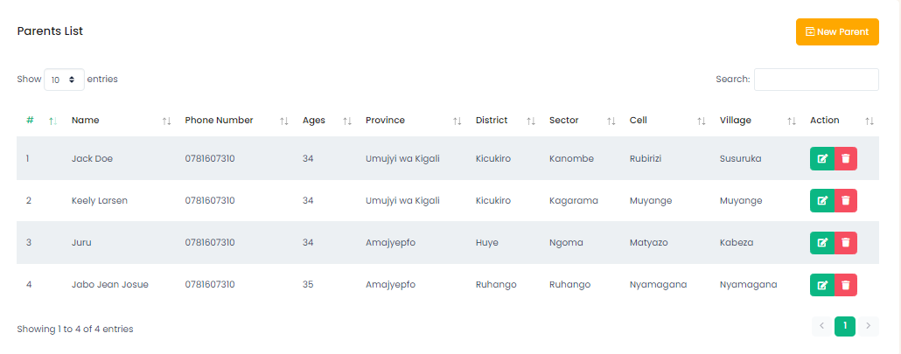

Figure 19: List of parents

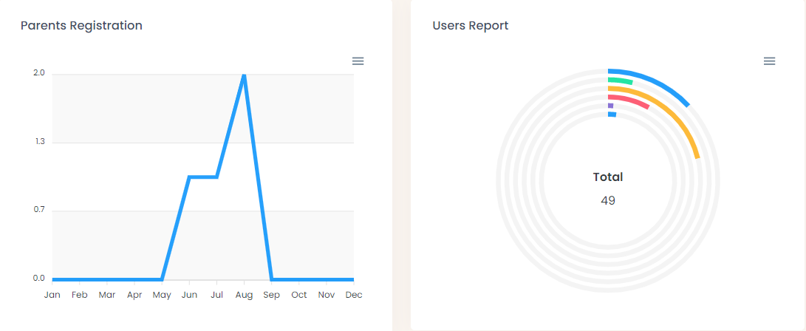

Figure : Parent and User Dashboard

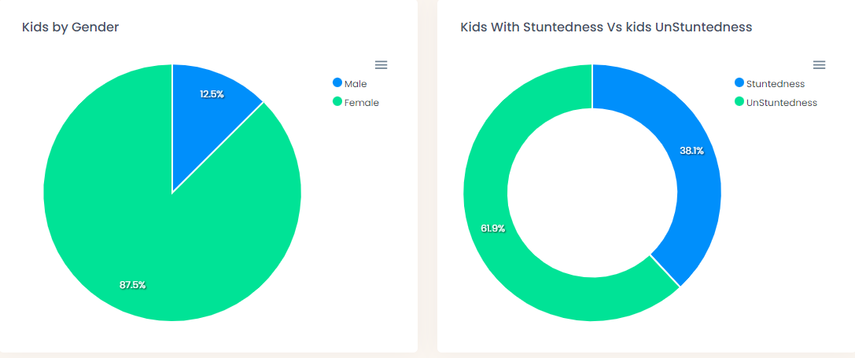

Figure : Children Dashboard

## **Software Testing**

Software tests play an important role in software designing. They help to verify the effectiveness of the software to see if it actually does what it was supposed to solve.

Listed are key aspects to take into consideration in software testing

* Does the application meet the requirements that guided its design and development?
* Does the application work as expect?
* Can the application be implemented with the same characteristics and satisfies the needs of the stakeholders?

The following are some software testing

**The Unit Test:** Unit testing is a process to ensure the proper functioning of particular software or a portion of a program. It is a method by which individual units of source code, sets of one or more computer program modules together with associated control data, usage procedures, and operating procedures, are tested to determine if they are fit for use. In other words, every small component that can be compiled with the goal to know that every unit matches to its specifications, and to know if there are logical mistakes. Indeed, the unit test is

an efficient means that permits to detect the maximum possible mistakes. The application has been checked with the unit test at each piece of the code written.

**The Integration test**: is the phase in software testing in which individual software modules are combined and tested as a group. This test is useful to check the assembly of the different part of the software. It is also a progression of tests, in which the software and hardware components are collected and tested until the entire system is tested. The application modules have been successively tested until completion to ensure that the whole constituted by the assembled software components answers to the required functional and technical specifications.

**The Validation test:** The last test phase has the role of validating the software in its external environment. The product has been put in the final situation in order to verify if it perfectly answers the needs expressed in the first phase. The validation test is important, since it is necessary to verify if the setting up of the application corresponds to the expressed needs. For example, the national Id should be 16 digits and the email address should contain @ and ends with Gmail, yahoo.com. The application has been tested in its entirety, and it is in this way that we noticed that the progress of operations done corresponds to the functional specifications.

## **Software and Hardware compatibility requirements**

**Client-side requirements**:

* A web browser (Mozilla Firefox, Google Chrome, Torch, etc.)
* Operating system (Windows xp, 7, 8 and 10; Linux, iOS).
* Microprocessor Intel 2 (minimum)
* A RAM of 512 Megabyte(minimum)
* A hard disk of at least 1Gigabyte of free space
* Intel Core i3 processor (minimum)

**Server-side requirements**:

* A Web server which supports Apache Tomcat;
* MYSQL SERVER 5.5;
* Network cark: 1GB/Second;
* RAM: 1GB minimum;
* 2GB or more free hard disk space.

# **CHAPTER 5**

# **CONCLUSION AND RECOMMENDATIONS**

## **Conclusion**

The main purpose of this project is to design and implement a web application which is Analytical System for Stunted Growth from the analysis of the current system’s weaknesses. The goals have been achieved with a practical solution as shown in the pictures in the previous chapter. Different methods such as observation, questioning, and documentation were used to detect visual problems in the current system. After seeing the problems, the analysis was done using UML to get a sufficient solution for the development of the new system using php expressions. Different tests were done to make sure if the developed system solves the problems encountered in existing system, we found that results were positive.

This project is divided in five parts. First part introduces entire project. Second part analyzes the literature review. Third part expresses methodology and system analysis. Fourth part shows the result of implementation within application design. Lastly is conclusion and recommendation.

As technology progress day to day, the web application also advances and allows the development of a new system based on computer from manual. Those applications had provided good services and answer the problems of manual approach. Application software is designed and implemented by different tools. In new system, data or information are organized into database for future use.

Even though my project has reached the scope settled, the system still needs more features to achieve a satisfied result. For the time given, some problems of current system have been solved. This means that new researchers who will contribute on this project can do better.

I put an end to this work by thanking all those who helped me in one way or another to carry out this work to the end. All my thanks go to all of you.

To conclude, I can affirm that Analytical System for Stunted Growth has been fully implemented and developed as per the procedures clarified in the previous chapters.

## **Recommendations**

From the results of this study the following recommendation are formulated to:

Decision makers (Ministry of Health and partners)

Stunting is still a matter of concerns, and a crosscutting issue. Therefore, it is recommended that the MoH should work with other partners (Ministry of Local Governments) to improve socioeconomic status of the population as this would ease the access to food. Additionally, the ministry of health in partnership with ministry of infrastructure should work hand in hand to improve water and sanitation infrastructure. The Ministry of health through the community health workers and nursing staff working close to community should benefit refresher course on stunting and help them in promoting water sanitation and hygiene in the population.

1. MOH continue to delivery different message regarding malnutrition, complementary feeding through social media.
2. Community health workers should emphasize on home visit, family with children under 5years by assessing anthropometric measures, pregnancy women with continuous health education.
3. Local authorities and community health workers to emphasize on Akarima k igikoni, ibimina, umugoroba w’ababyeyi by introducing topics related to nutrition, hygiene, sanitation and complementary feeding practices,
4. Local authorities to emphasize and distribute Girinka munyarwanda to poor family and share milk from those without to help children to gain some animal products
5. The ministry of agriculture and veterinary should sensitize households in Rwanda on innovative and cost-effective agricultural and livelihood strategies, for example, Akarima kigikoni to facilitate easy access of vegetables and fruits which will in turn improve micronutrient intake and dietary diversity of the children.
6. Local Authorities should sensitize the population to listen some emission like Urunana where there is educative message.

# **REFERENCES**

**Websites**

* PHP (2019, July 17). Retrieved from google
* https://laravel.com
* PHP Laravel (PHP Backend framework). (2019, July 17). Retrieved from google
* https://www.php.net
* Class diagram. (2019, March 22). Retrieved from Wikipedia: https://en.wikipedia.org/wiki/Class_diagram
* data dictionary. (2019, March 26). Retrieved from search micro services: https://searchmicroservices.techtarget.com/definition/data-dictionary
* JavaScript (2019, June 14). Retrieved from Wikipedia: https://en.wikipedia.org/wiki/JavaScript
* jQuery. (2019, June 14). Retrieved from Wikipedia: https://en.wikipedia.org/wiki/JQuery
* MySQL. (2019, May 11). Retrieved from search oracle: https://searchoracle.techtarget.com/definition/MySQL
* Use case. (2019, March 20). Retrieved from search software quality. TechTarget: https://searchsoftwarequality.techtarget.com/definition/use-case

**Books**

* Alan Dennis, et al., (2012). *System Analysis and Design (5th).* John Wiley & Sons, Inc.
* Joseph Valacich, Joey George (2016). *Modern Systems Analysis and Design(8th).* Pearson.
* Aurum, A. et al., (2013). *Managing Software Engineering Knowledge.* Sping Science & Business Media.
* Ayesh, A. (2000). *In Essential Dynamic HTML fast;Cascading Sytle Sheets(pp.78-90).* London: In Essential Dynamic HTML fast.

# **APPENDICES**

## **Curriculum Vitae**

**Yvan Pierre JURU**

Rwandan | KK 223 St. | +250780586009

Juru.yvan@gmail.com | Yvan Pierre Juru |

**SUMMARY**

Currently pursuing a Bachelor’s degree in Information Technology at the Adventist University of Central Africa. I'm passionate about programming and User experience. I love learning and trying new things, proven potential to work within a team with some knowledge of effective communications, data analysis, and project & people management.

**EDUCATIONAL BACKGROUND**

**Adventist University of Central Africa–** Kigali, Rwanda **2018 – present**

BSc. Information Technology

**Nyanza Technical School-South**, South, Rwanda **2015 – 2017**

A2. Electronic & Telecommunication

**Petit Seminaire Saint Vincent Ndera,** Kigali, Rwanda **2012 2014**

O’Level

**Relevant Coursework**: python programming language, database management, Operating System, Java Programming language, ASP.NET, Linux Administration, Computer Hardware

**SKILLS**

|  |  |  |
| --- | --- | --- |
| * Analytical Skills * Communication * Web development * IT Support | * Programming * Web Design * Graphic Design * Troubleshooting | * Organization & research * Networking fundamentals * Database management * Networking |

**INTERESTS**

|  |  |  |
| --- | --- | --- |
| * Reading * Gaming | * Education * Music | * Browsing * Photography |

**LANGUAGES**

|  |  |  |
| --- | --- | --- |
| * Kinyarwanda– Native * French – Fluent | * English- Fluent * Kiswahili- Beginner |  |

**OTHER SKILLS**

|  |  |  |
| --- | --- | --- |
| * Computer literate: Windows applications and Microsoft skills. * Communication skills |  |  |

**CERTIFICATION**

I certify that, to the best of my knowledge and belief, the information given above in the Curriculum vitae is correctly.

**JURU Yvan Pierre**